First Term [Final Project 1]



Mastering Embedded System Online Diploma



<www.learn-in-depth.com> [By Eng.K.S.]

Eng. Mohamed Abd El Hakeem El Said Ali.

My Profile: [eng.mohamedhakim2122000@gmail.com (learn-in-depth-store.com)](https://www.learn-in-depth-store.com/certificate/eng.mohamedhakim2122000%40gmail.com)

Pressure Controller

# A screenshot of a computer Description automatically generatedFirst Stage [System Architecting]:

1. Case Study: [With Customer]
2. Method
3. Requirement
4. Space Exploration
5. System Analysis
6. System Design

## Case Study: [From Customer]

- A” client” expects you to deliver the software of the following system: -

* Specification (from the client) :

1. A pressure controller informs the crew of a cabin with an alarm when the pressure exceeds 20 bars in the cabin.
2. The alarm duration equals 60 seconds.
3. keeps track of the measured values.

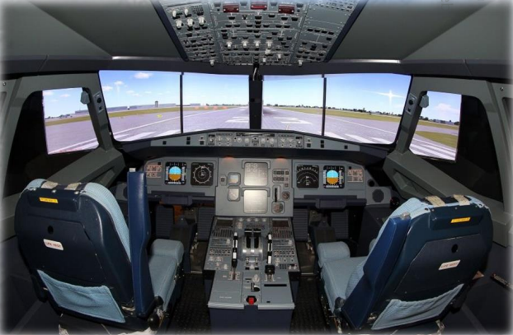

-My Assumptions:

1. The controller set up and shutdown procedures are not modeled.
2. The controller maintenance is not modeled.
3. The pressure sensor never fails.
4. The alarm never fails.
5. The controller never faces a power cut.

- Versioning • The ”keep track of measured value” option is not modeled in the first version of the design

## A diagram of software testing Description automatically generatedMethod:

- I would work with the Vmodel method to apply my system design.

## Requirements:

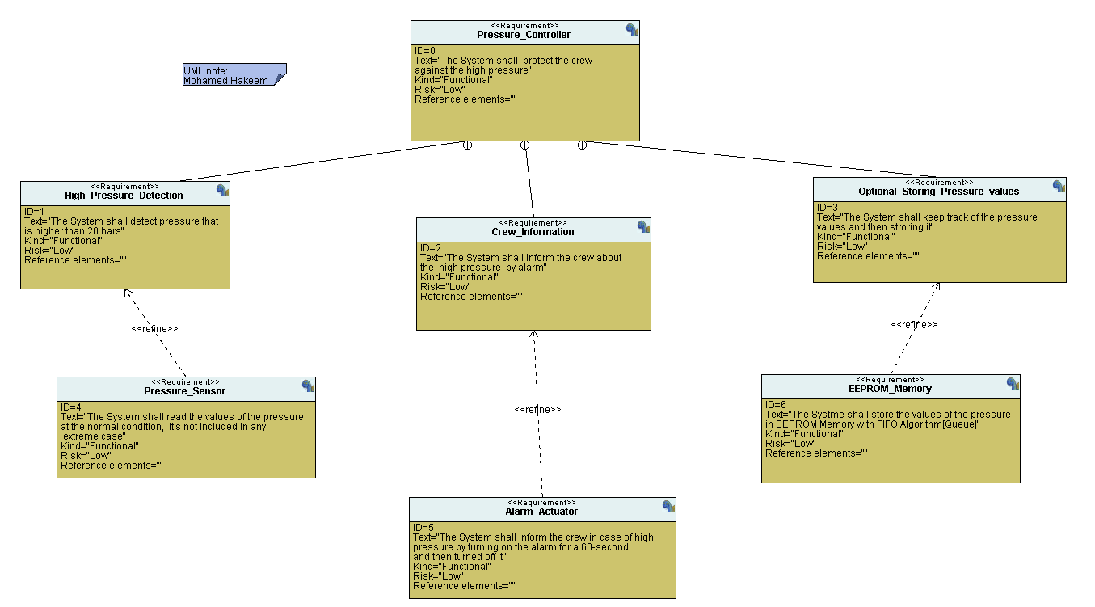

## Space Exploration:

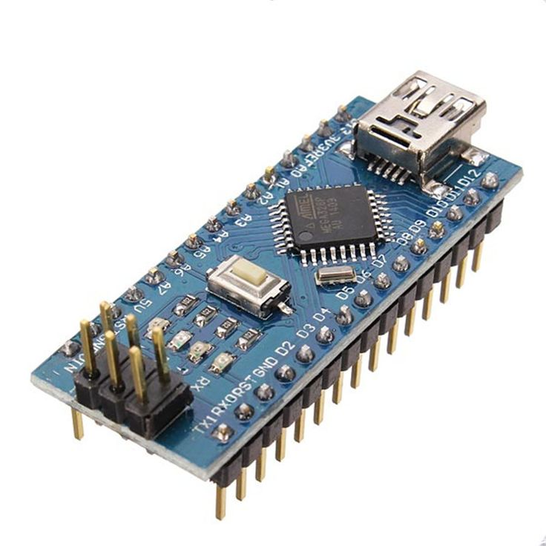-I see that Board "STM32F103C8T6" "Cortex_M3" is Very suitable for this Case study.

* Core: 32-bit ARM Cortex-M3 CPU, running at up to 72 MHz
* Memory: 64 KB of Flash memory and 20 KB of SRAM.
* Peripherals: Includes two 12-bit ADCs, three general-purpose 16-bit timers, one PWM timer, and various communication interfaces like I2C, SPI, USART, USB, and CAN.
* Power: Operates from a 2.0 to 3.6 V power supply and includes several power-saving modes.

## System Analysis:

1. 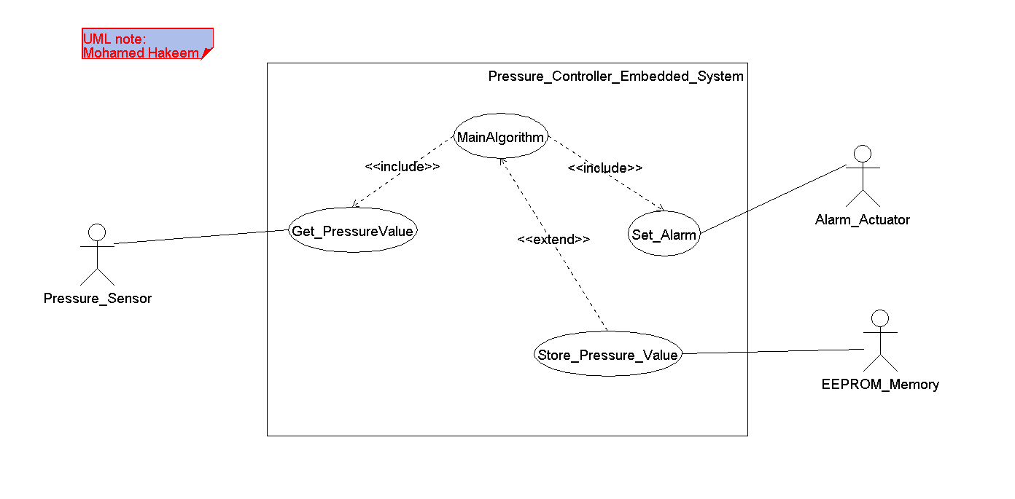Use Case:
2. Activity Diagram:

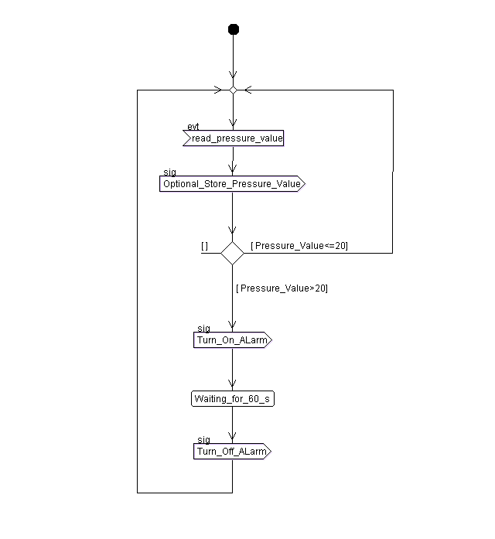

1. 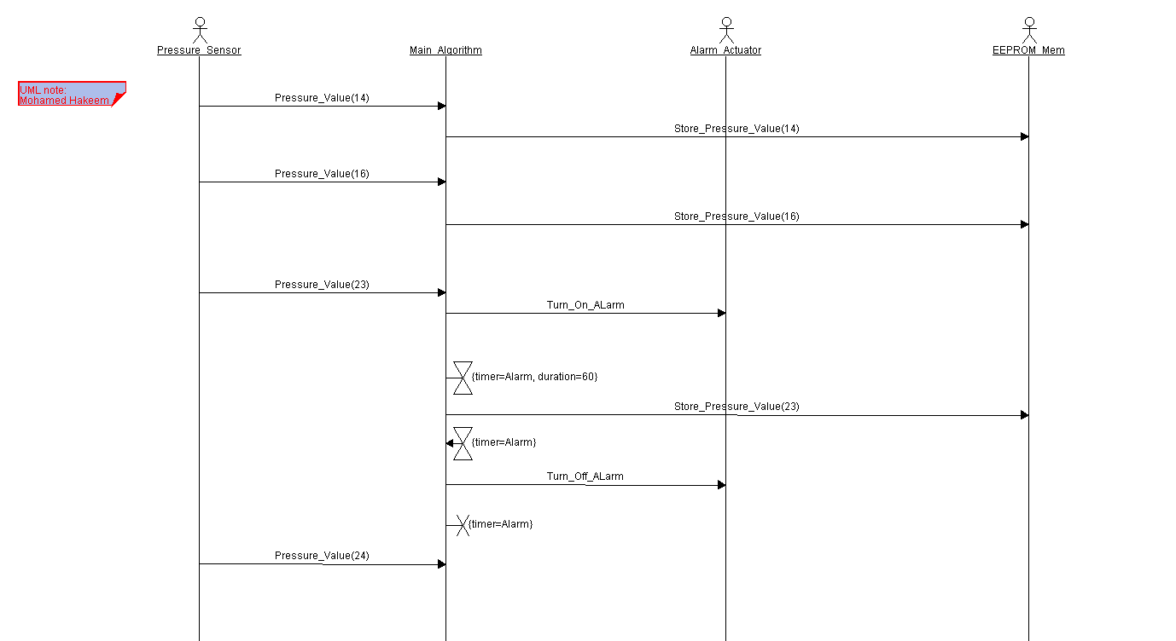Sequence Diagram:

## System Design:

1. 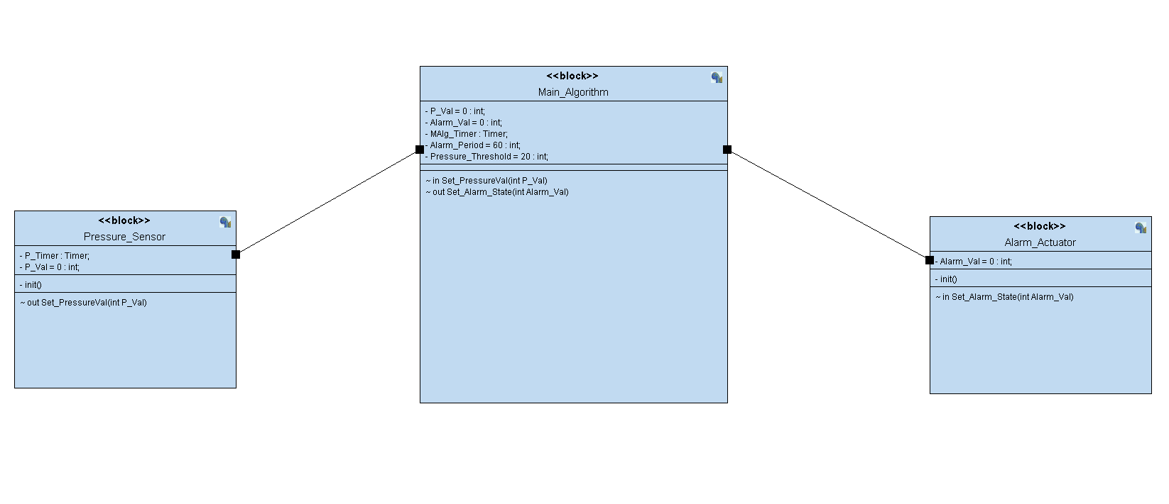Block Diagram:
2. Pressure Sensor:

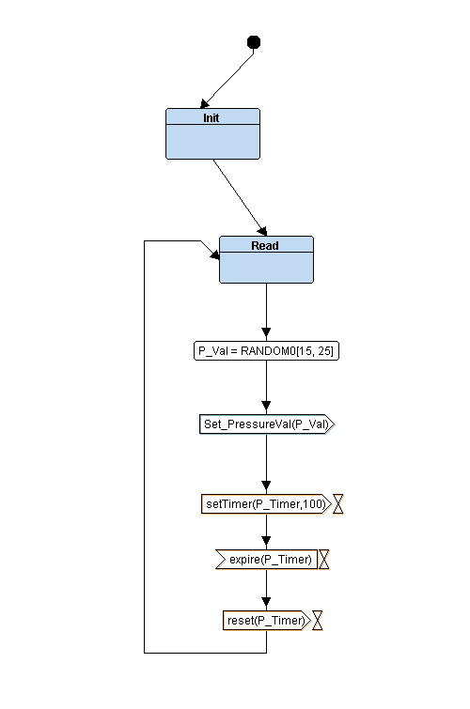

1. Main Algorithm:

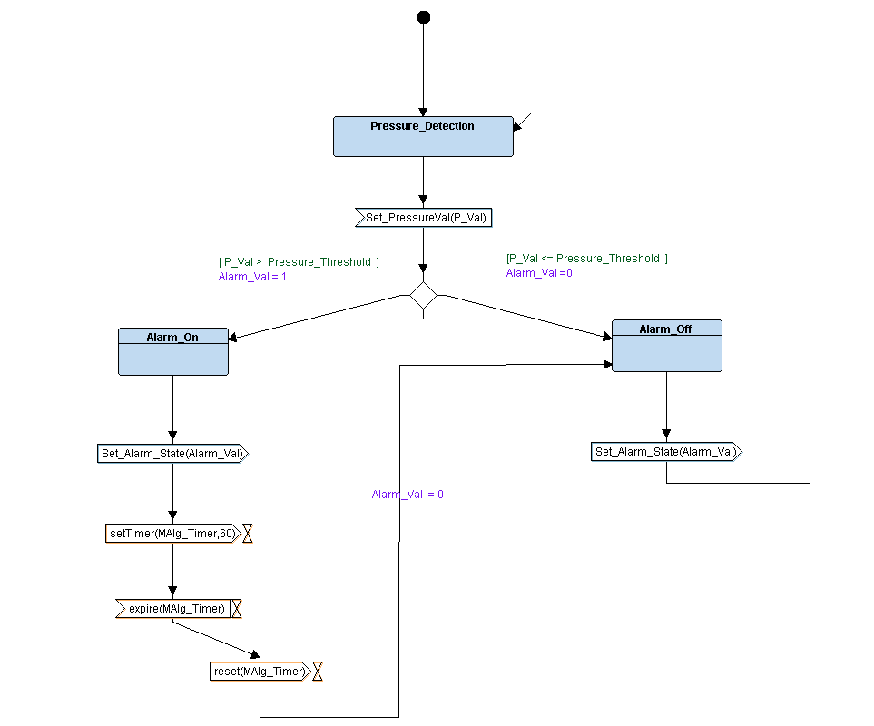

1. Alarm Actuator:

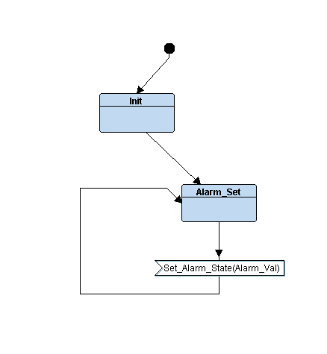

# Second Stage [Embedded Implementation]:

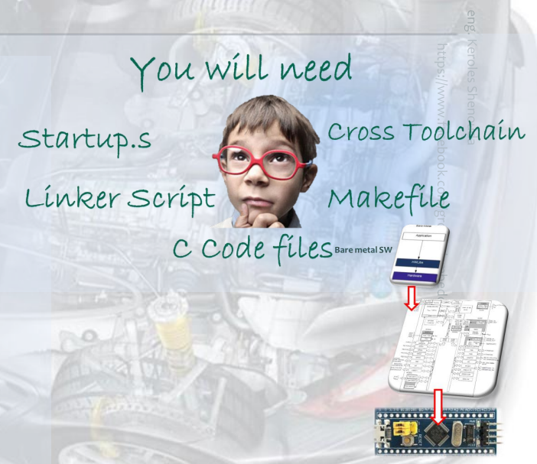

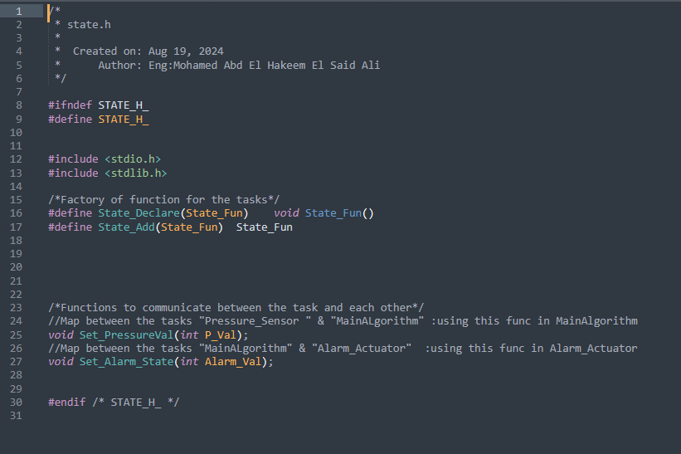-State.h:

1. 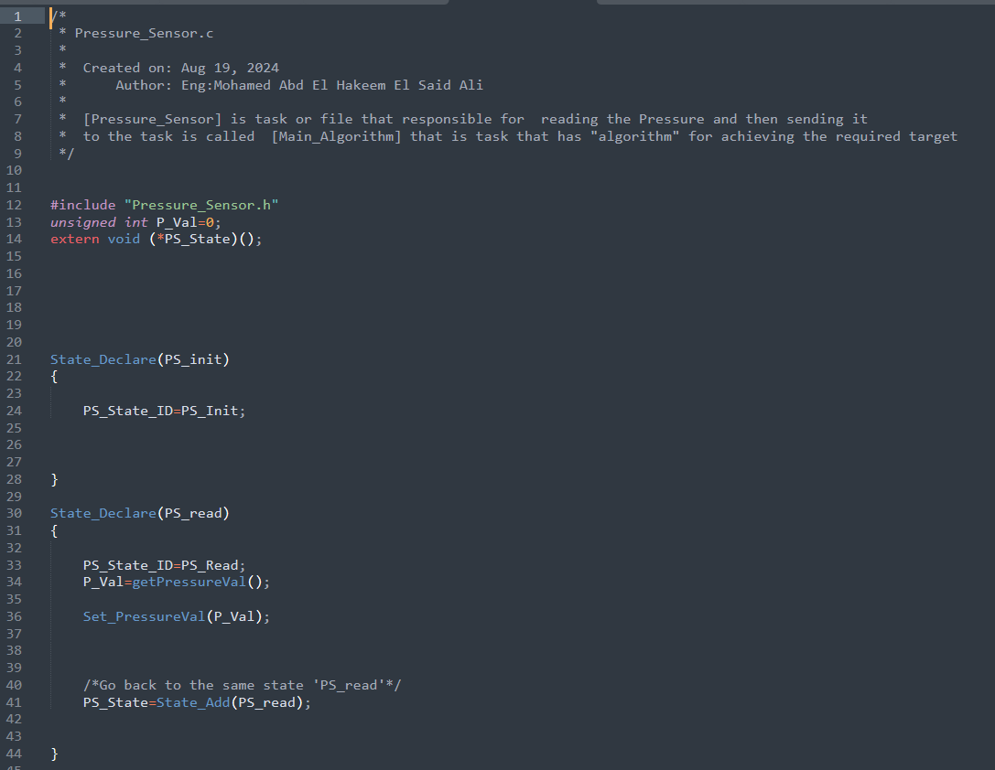Pressure Sensor.c:





1. 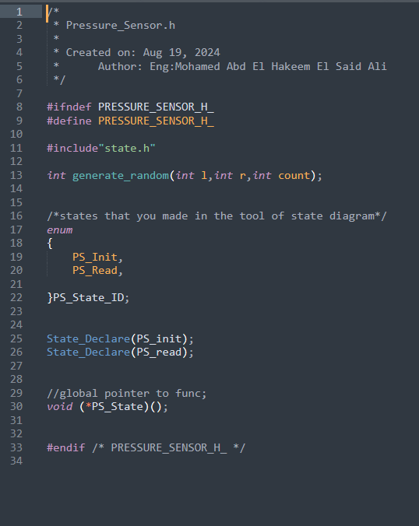Pressure Sensor.h:
2. 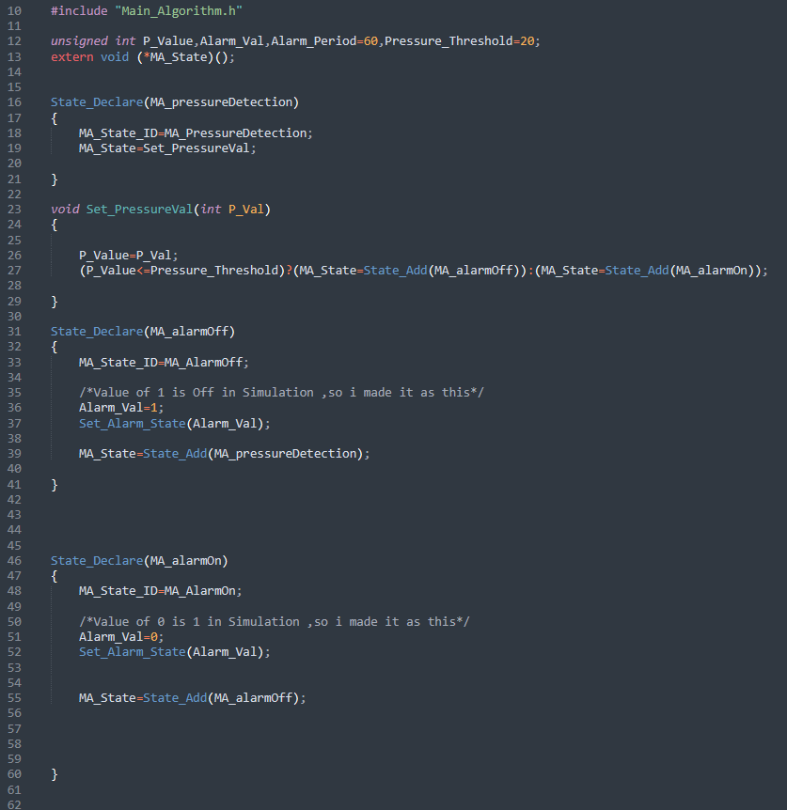Main_Algorithm.c:



1. 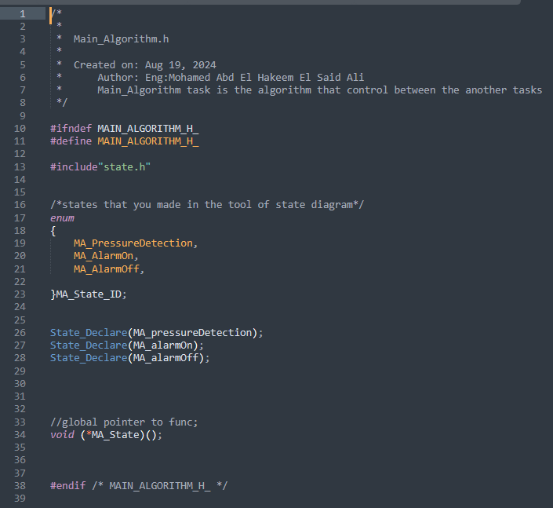Main_Algorithm.h:
2. 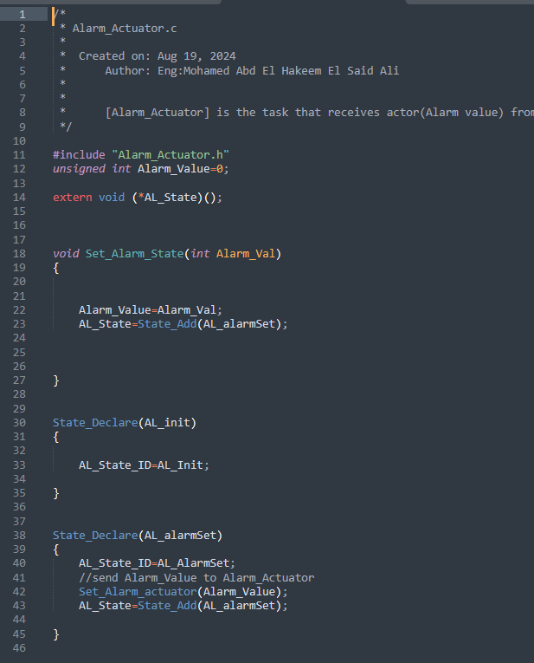Alarm_Actuator.c:





1. 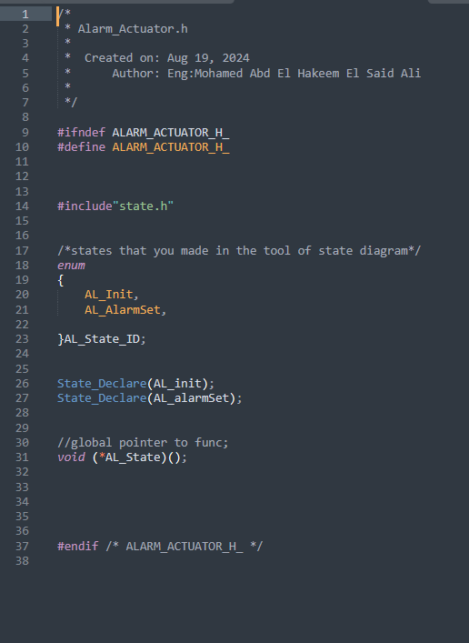Alarm_Actuator.h:
2. 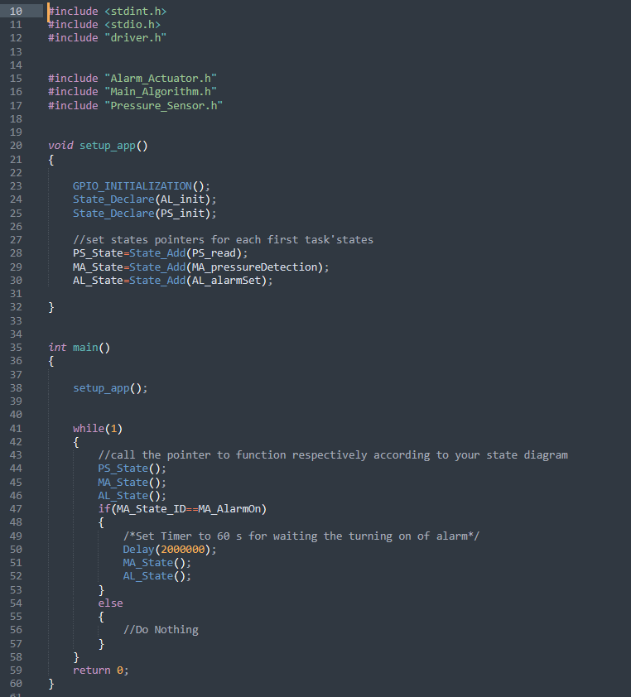main.c:

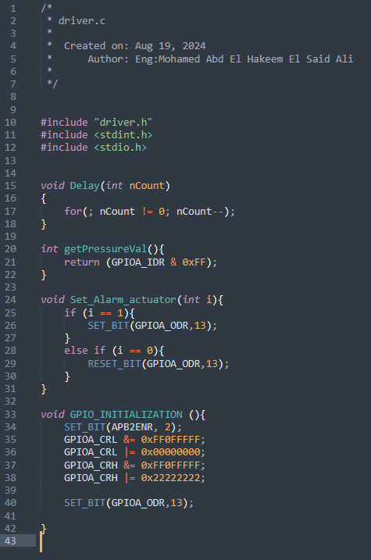

1. driver.c:
2. 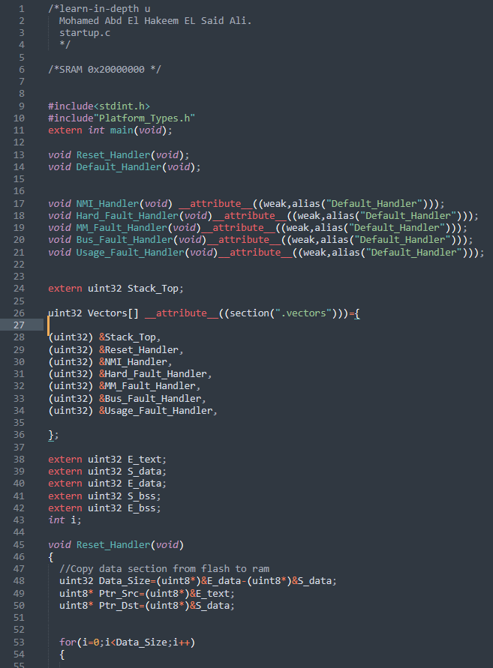Startup.c:

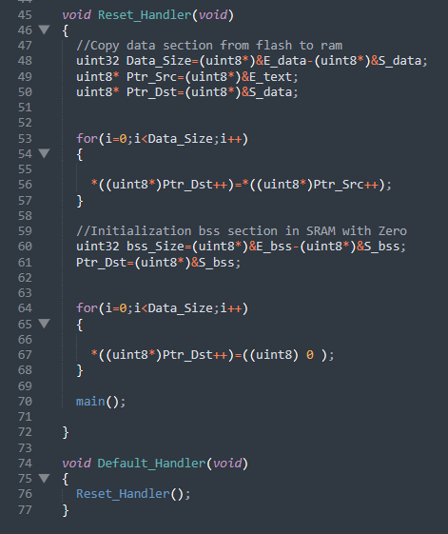

1. 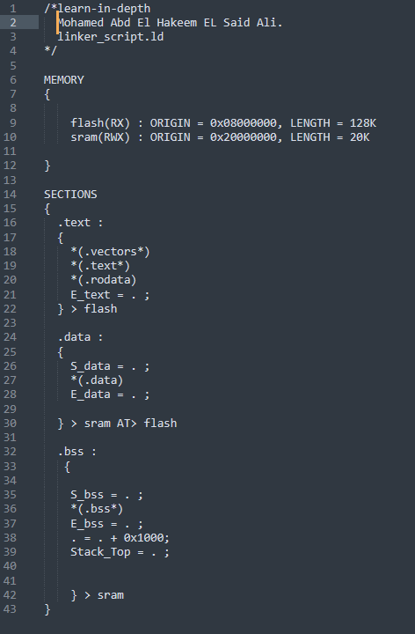Linker_Script.ld:
2. 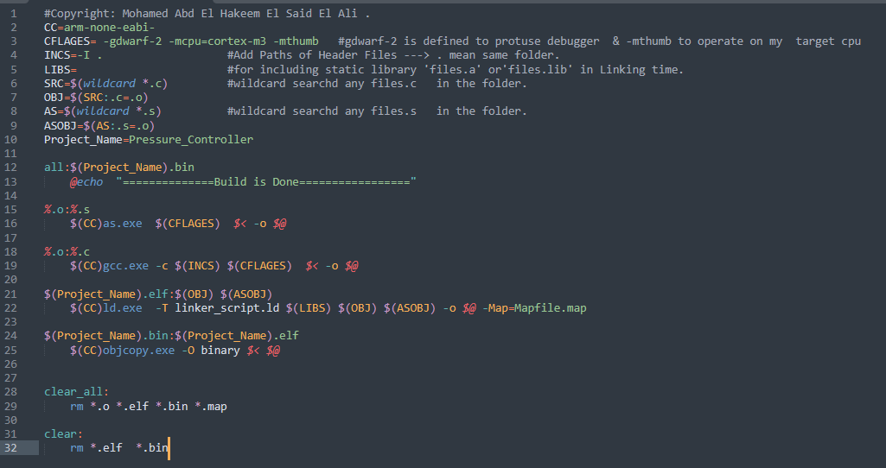 Makefile:

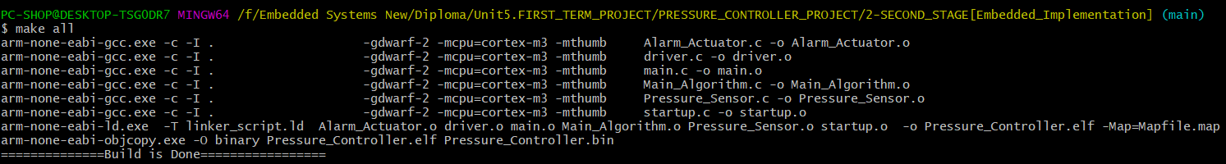12-Building By tool chain[arm-none-eabi-x]:

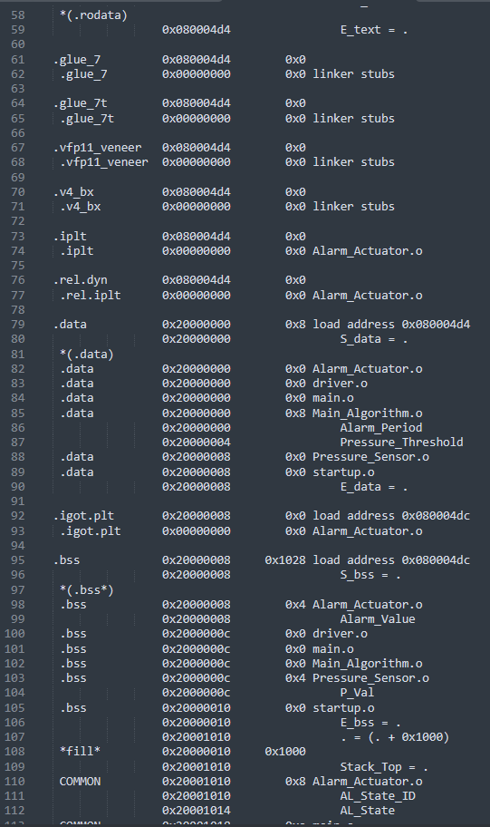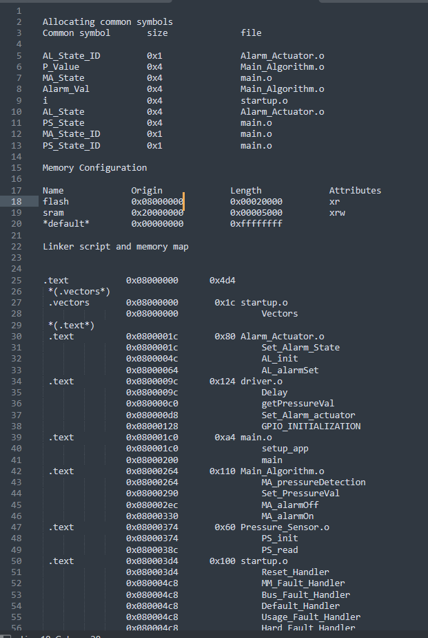13-Mapfile.map:

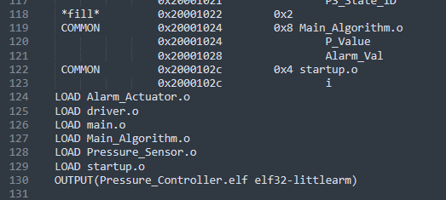

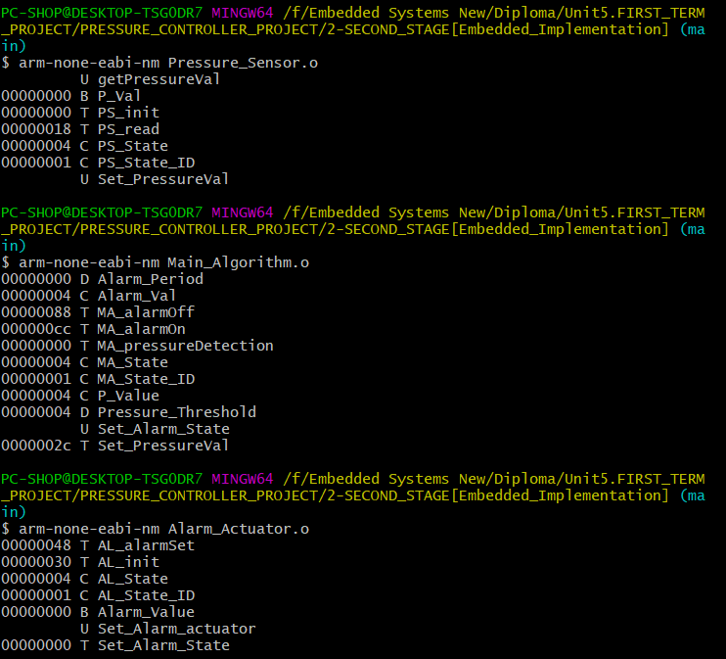14-Symbol Tables:

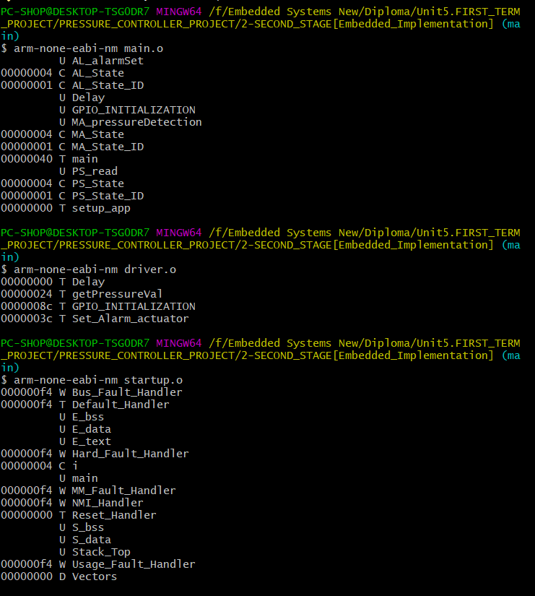

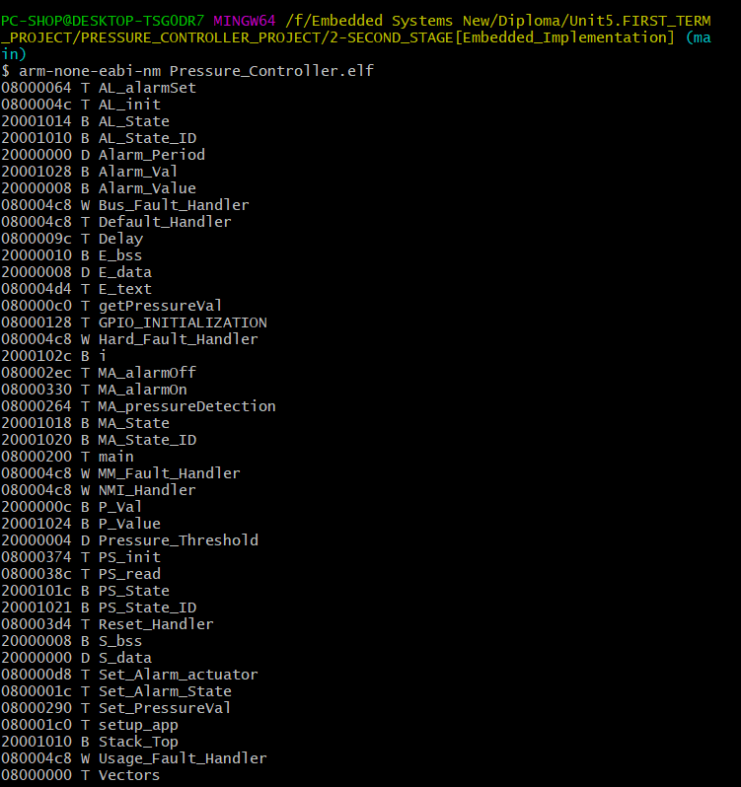

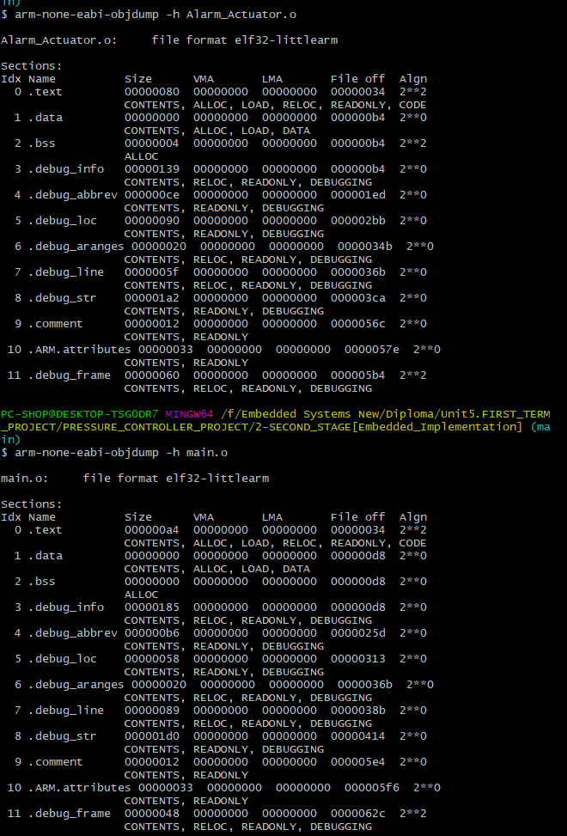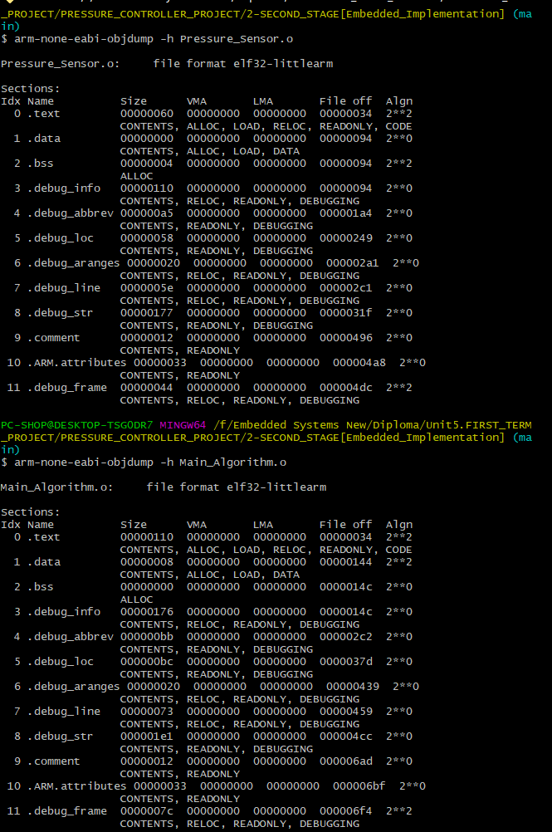15-Section_Tables:

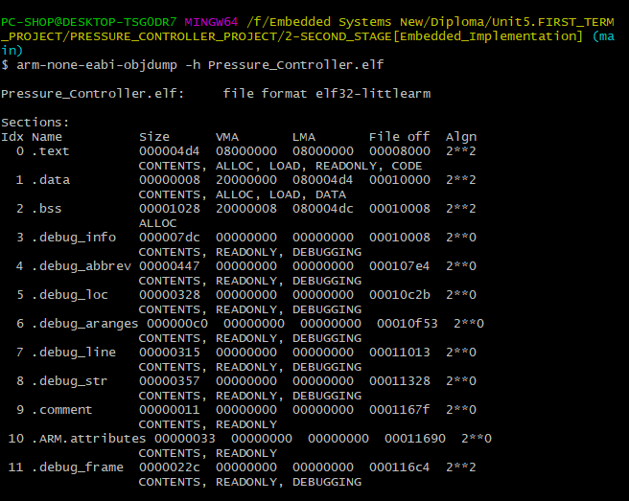

# Third Stage [Simulation in Proteus]:



